10/16/2013

**48 Hour Phoenix Temperature Forecast**

# Model Selection and Forecasts for October 8-9, 2013

Orange Team 6:

*Team Lead:* Phillip **Domschke**

*Other Contributors:* Marc Zimmerman, Steve Neola, Wes Ledebuhr, Jacob Frost

# TABLE OF CONTENTS

Model Selection and Forecasts for October 8-9, 2013 0

TABLE OF CONTENTS 1

EXECUTIVE SUMMARY 2

ANALYSIS 3

Exploratory Analysis 3

Model Selection 3

48 Hour Temperature Forecast 5

CONCLUSION 6

Appendix A: 48 Hour Temperature Forecast 7

# 

# EXECUTIVE SUMMARY

In this report, we will show how we developed a time series model to forecast the hourly temperature in Phoenix, AZ for October 8-9, 2013 using data from September 23, 2013 through October 7, 2013. To determine how close our forecast was to the actual temperature, we calculated the Mean Absolute Percentage Error (MAPE). Our model produced a MAPE of 2.879% for the October 8-9 forecasts. When testing our model on October 6-7, 2013, the MAPE hovered between 4-5% for our top models. Given this variability in the MAPE, we recommend continuing to monitor and refine the model for future dates in addition to including other variables to enhance the predictions.

# ANALYSIS

## Exploratory Analysis

We started by plotting the temperature data across time to see the macro picture of the data. It was fairly clear that the data were stationary as there is mean reversion and a fairly constant variance.

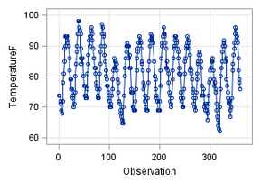

Graph 1: Hourly Temperature Data from September 23, 2013 through October 7, 2013.

## Model Selection

Given the data were stationary and that the only variable we were only using was temperature, we knew that we could begin our modeling process. To help determine which type of model was most appropriate, we plotted the Autocorrelation Function (ACF), Partial Autocorrelation Function (PACF) and Inverse Autocorrelation Function (IACF) as shown in Graph 2.

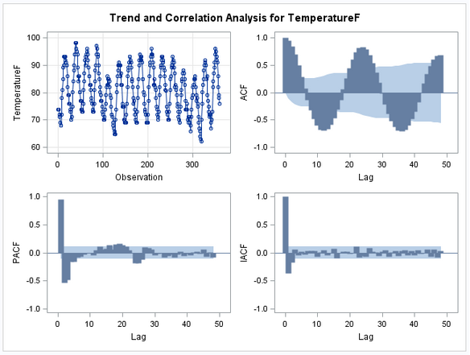

Graph 2: ACF, PACF, IACF plots for Temperature

The (ACF) plot indicated that there was a cyclical pattern every 24 hours that needed to be addressed. The PACF and IACF plots showed several significant lags that would need to be addressed when building the model. To address the cyclical pattern, we used differencing to compare the corresponding hours across days. As shown in Graph 3 below, the cyclical nature that was present in the previous ACF plot was no longer significant.

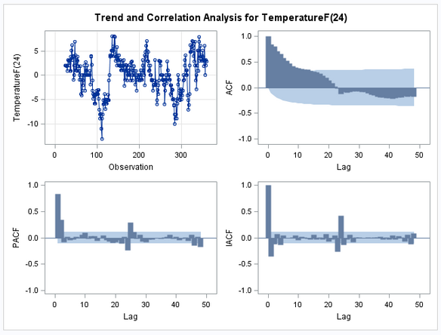

Graph 3: Hourly Data once 24 hour differencing was applied

We then turned to modeling the residuals via Autoregressive and Moving Average functions since there were significant lags in that remained in the PACF and IACF plots. After trying multiple types of autoregressive and moving average models, we found that the autoregressive lags (P) at points 1, 2, 24 and moving average lags (q) at 4, 23, 24 were optimal in that no significant lags remained and the white noise plot indicated that there was only white noise left in the residuals (since there were no points above .05). At this point in the modeling process, we concluded that there was no additional modeling of the residuals that we needed to do before testing our models on the validation data sets. The residual and white noise plots are shown on the following page.

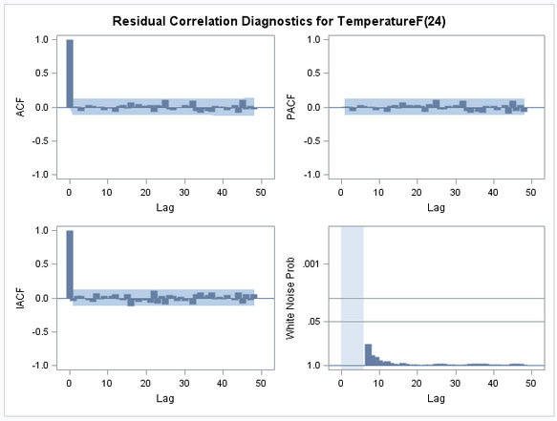

Graph 4: Residual Correlation Diagnostics for Temperature with final AR-MA model applied

## 48 Hour Temperature Forecast

After selecting the top models, we used these to forecast the temperature in Phoenix for the next 48 hours (October 8-9, 2013). When comparing the forecasted temperatures to the actual temperatures, our best model returned a MAPE of 2.879%. A graphical representation is shown in Graph 5 below, and the actual forecasts are shown in Appendix A: 48-hour forecast. It is important to note that the actual temperature for 2:51 AM on October 8, 2013 was missing in the data set we received. We provided a forecast for this time period, but we could not factor that hour into our scoring calculation.

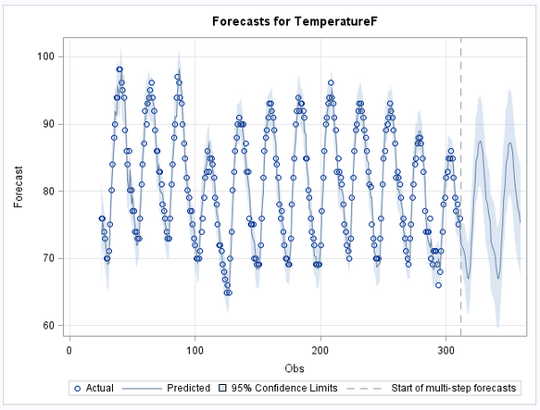

Graph 5: 48 Hour Temperature Forecast for Phoenix

# CONCLUSION

This report laid out the methodology of the time series analysis for the Phoenix temperature forecasts. While the final MAPE for the requested date range was fairly low, we recommend continuing to monitor and refine the model as necessary to improve the performance in future forecasts.

# Appendix A: 48 Hour Temperature Forecast

|  |  |  |  |
| --- | --- | --- | --- |
| Time (MST) | Actual Temp | Forecast | Difference |
| 12:51 AM | 75 | 73.2466 | 1.7534 |
| 2:51 AM | Missing | 71.5348 | Missing |
| 1:51 AM | 72 | 70.9334 | -0.9334 |
| 3:51 AM | 70 | 68.886 | -0.886 |
| 4:51 AM | 68 | 68.5641 | -0.5641 |
| 5:51 AM | 68 | 67.7387 | -0.8387 |
| 6:51 AM | 66.9 | 67.5183 | 3.5817 |
| 7:51 AM | 71.1 | 71.052 | 4.848 |
| 8:51 AM | 75.9 | 76.0132 | 2.9868 |
| 9:51 AM | 79 | 79.7018 | 3.1982 |
| 10:51 AM | 82.9 | 82.674 | 5.326 |
| 11:51 AM | 88 | 85.044 | 4.056 |
| 12:51 PM | 89.1 | 88.1559 | 2.8441 |
| 1:51 PM | 91 | 89.7901 | 1.2099 |
| 2:51 PM | 91 | 91.3514 | 0.5486 |
| 3:51 PM | 91.9 | 91.1035 | 0.7965 |
| 4:51 PM | 91.9 | 90.1776 | -0.1776 |
| 5:51 PM | 90 | 89.2365 | -1.2365 |
| 6:51 PM | 88 | 86.8998 | -3.9998 |
| 7:51 PM | 82.9 | 83.8502 | -1.8502 |
| 8:51 PM | 82 | 79.7625 | 1.2375 |
| 9:51 PM | 81 | 78.2442 | -2.3442 |
| 10:51 PM | 75.9 | 76.7266 | -1.7266 |
| 11:51 PM | 75 | 75.462 | -2.462 |
| 12:51 AM | 73 | 72.5821 | 0.4179 |
| 1:51 AM | 73 | 70.966 | 0.134 |
| 2:51 AM | 71.1 | 70.3796 | 2.6204 |
| 3:51 AM | 73 | 68.346 | 3.654 |
| 4:51 AM | 72 | 68.054 | 1.946 |
| 5:51 AM | 70 | 67.2632 | 0.7368 |
| 6:51 AM | 68 | 67.0746 | 4.9254 |
| 7:51 AM | 72 | 70.6345 | 5.2655 |
| 8:51 AM | 75.9 | 75.648 | 5.352 |
| 9:51 AM | 81 | 79.3663 | 3.5337 |
| 10:51 AM | 82.9 | 82.3722 | 2.5278 |
| 11:51 AM | 84.9 | 84.7694 | 2.3306 |
| 12:51 PM | 87.1 | 87.8997 | 0.1003 |
| 1:51 PM | 88 | 89.5614 | -3.5614 |
| 2:51 PM | 86 | 91.1497 | -7.1497 |
| 3:51 PM | 84 | 90.9208 | -8.0208 |
| 4:51 PM | 82.9 | 90.0071 | -9.0071 |
| 5:51 PM | 81 | 89.0777 | -10.0777 |
| 6:51 PM | 79 | 86.7615 | -9.7615 |
| 7:51 PM | 77 | 83.7153 | -8.7153 |
| 8:51 PM | 75 | 79.6356 | -5.7356 |
| 9:51 PM | 73.9 | 78.1135 | -6.1135 |
| 10:51 PM | 72 | 76.5996 | -6.5996 |
| 11:51 PM | 70 | 75.3301 | -75.3301 |